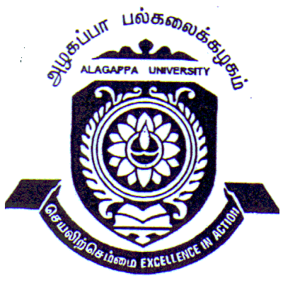
CENTRE FOR WOMEN’S STUDIES
DEPARTMENT OF WOMEN’S STUDIES
ALAGAPPA UNIVERSITY, KARAIKUDI
(Re-accredited with ‘A’ Grade by NAAC)

Short Term Course on Application of SPSS and Feminist Research Methodology
Dates: 25th September to 1st October, 2015
Venue: Women’s Studies Conference Hall, Alagappa University

We are pleased to inform you that the Centre for Women’s Studies is conducting a short term course on Application of SPSS and Feminist Research Methodology for researchers to improve their capacities in Social Science Research and Feminist Research.

Objectives of the Course:
- To enhance the following:
- Statistical Methods (from the Basics to Intermediate level)
- Different Qualitative & Quantitative Research Techniques
- Different Methods of Data Collection
- Management of Research Data
- MS Excel – Data Analysis Package
- SPSS Statistics & Hands-on working
- Feminist Research Methodology
Course Content
Qualitative and Quantitative Research Methods, Identification of Relevant Research Problems, Designing Research, Different Sampling Techniques, Different Data Collection Techniques, Management of Research Data, Basic Statistics using MS Excel & SPSS Statistics, Comparison of Means – Different Tests (Parametric & Non-Parametric), Testing of Hypothesis, Reliability & Validity, Writing a Quantitative Research Thesis, Writing a Quantitative Research paper for Publication; and Preparing Research Reports
Profile of Participants
Research Guides & Researchers including Post-Graduate, M.Phil. and Ph.D. Students
Registration
Interested participants may apply in the format prescribed below through e-mail/post before 20th September, 2015. Fees of Rs.1000 may be paid by DD drawn in favour of the “Course Director, Centre for Women’s Studies, Alagappa University”. Fees include costs of participant training materials, stationery, lunch and refreshments on the seven training days.
Accommodation
The accommodation for the out station participants can be arranged on request. Participants may also make their own arrangement.
Additional Information
- Participants may bring their own laptops.
- The course starts at 10.00 am on 25th September, 2015
- Certificate of Participation will be issued to those attending all sessions of the Workshop.
- Certificate of attendance will also be given, if needed, for availing leave.
For more information, if any, please contact:
Director, Centre for Women’s Studies, Alagappa University, Karaikudi-630003.
04565-224615, 223230. E-mail: cws.alukkdi@gmail.com

CENTRE FOR WOMEN’S STUDIES
ALAGAPPA UNIVERSITY
(Re-accredited by Grade ‘A’)
KARAIKUDI – 630 003

Short Term Course on Application of SPSS and Feminist Research Methodology
Dates : 25th September to 1st October, 2015
Venue: Women’s Studies Conference Hall, Alagappa University

Registration Form

Name:
Educational Qualification:
Designation:
Name of the Institution:
Official Address:
Telephone: (O) (M)
E-mail ID:
Accommodation Required: Yes / No
Registration Fee Details:
DD. No:
Rs. :
Bank:
Date: Signature

Completed Registration Form may be Submitted through E-mail or post by 20th September, 2015 to: Course Director, Centre for Women’s Studies, Alagappa University, Karaikudi-630003. E-mail: cws.alukkdi@gmail.com

